Research and Prediction of Stock Market using ML for Algorithmic Trading

Bishal Mohanty
Regd. No. 2001209106
8th Sem, CSE
bsl2908@gmail.com
Abhijit Mishra
Regd. No. 2001209062
8th Sem, CSE
abhijitmishra2000@gmail.com
Subhojit Das
Regd. No. 2001209208
8th Sem, CSE
subhojitdas1503@gmail.com

Supervised by Prof.(Dr) Bhagwat Prasad Chaudhury

Abstract — This paper explores the fusion of machine learning models, web scraping techniques, and front-end development in the context of stock market prediction. We investigate the efficacy of simple models like Logistic Regression, SVC and XGBoost along with complex ones like Long Short-Term Memory (LSTM), and technical analysis tools Moving Average Convergence/Divergence Oscillator (MACD) in forecasting stock prices. Additionally, we leverage web scraping to collect real-time market data and develop user-friendly front-end interfaces for data visualization. Our findings reveal the predictive power of these ML models and the importance of web scraping and front-end design in enhancing market analysis and decision-making. The convergence of these methodologies promises to revolutionize algorithmic trading strategies and empower investors in navigating the complexities of financial markets.

Introduction

The field of stock market prediction has witnessed a surge in interest due to the potential for leveraging advanced technologies to forecast market trends and facilitate informed decision-making. In this project, we embark on a journey to explore the application of machine learning (ML) techniques in predicting stock prices and capturing market dynamics. The aim is to develop robust predictive models that provide valuable insights to investors and analysts in navigating the complexities of financial markets.

Through this project, we address the growing demand for accurate and timely predictions in the stock market domain. By harnessing the power of ML algorithms, we seek to unlock patterns hidden within vast amounts of financial data, enabling us to forecast stock prices with greater precision and reliability. Additionally, we aim to enhance the accessibility and usability of our predictive models by leveraging modern web technologies to create intuitive front-end interfaces.

Project Overview

Objectives
Web Scraping: Data collection involved scraping stock market data from Yahoo Finance using Python's BeautifulSoup library.
Machine Learning Models: LR, SVC, XGBoost, LSTM, and MACD algorithms were applied to analyze historical data and predict future stock trends.
Front End Development: The project utilized the Streamlit library for creating an interactive front end to display stock metrics and predictions.

Methodology
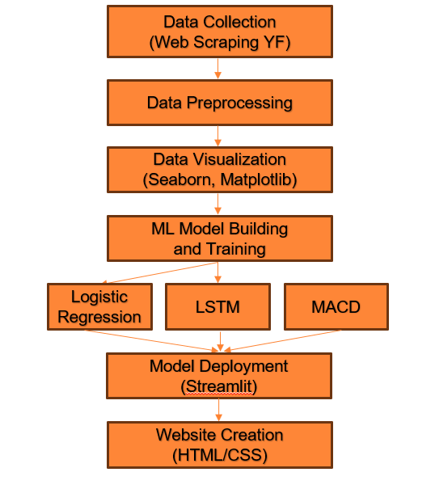
Fig 1. Yahoo Finance Script Scraping

Yahoo Finance Scraping
We utilized web scraping techniques to extract historical stock price data from Yahoo Finance. This involved automating data retrieval processes to gather real-time market data swiftly and efficiently.
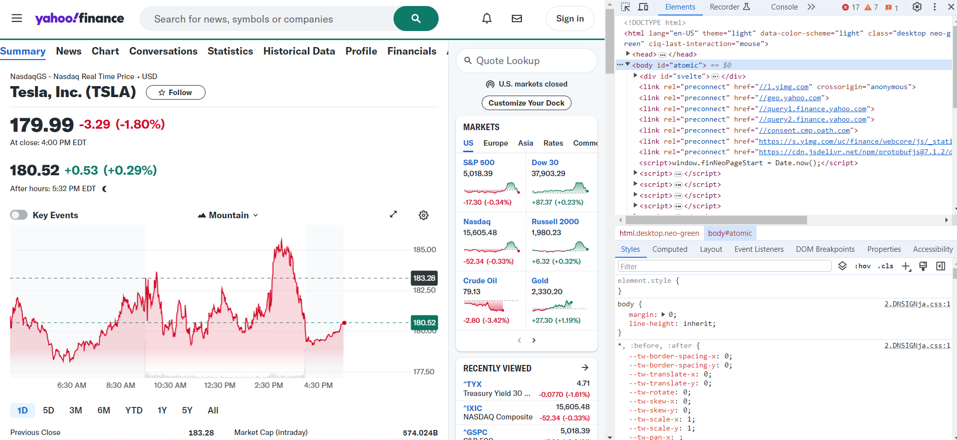
Fig 2. Yahoo Finance Script Scraping

Logistic Regression
Implemented logistic regression and SVC along with XGBoost models and achieved around 50% accuracy for validation in predicting stock trends.
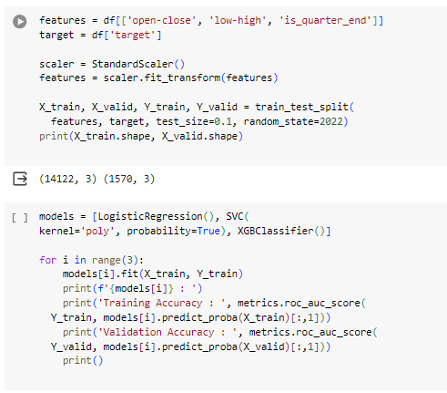
Fig 3. LR,SVC,XGBoost

Long Short Term Memory
Implemented Bidirectional Long Short-Term Memory (Bi-LSTM) layers with dropout regularization to detect complex temporal patterns in sequential data. This model architecture achieved an accuracy of 88% in forecasting stock prices. The implementation involved preprocessing the historical stock price data using Min-Max scaling to normalize the values. Subsequently, the data was divided into input sequences and corresponding target values. The Bi-LSTM model, comprising an LSTM layer followed by a fully connected layer, was trained using the Adam optimizer with a mean squared error (MSE) loss function. Over 100 epochs of training, the model learned to capture temporal dependencies and predict future stock prices. The trained model was then evaluated on the test data, and the predictions were compared with the actual stock prices. The resulting predictions and actual values were visualized using matplotlib, providing insights into the model's performance in capturing stock price trends.
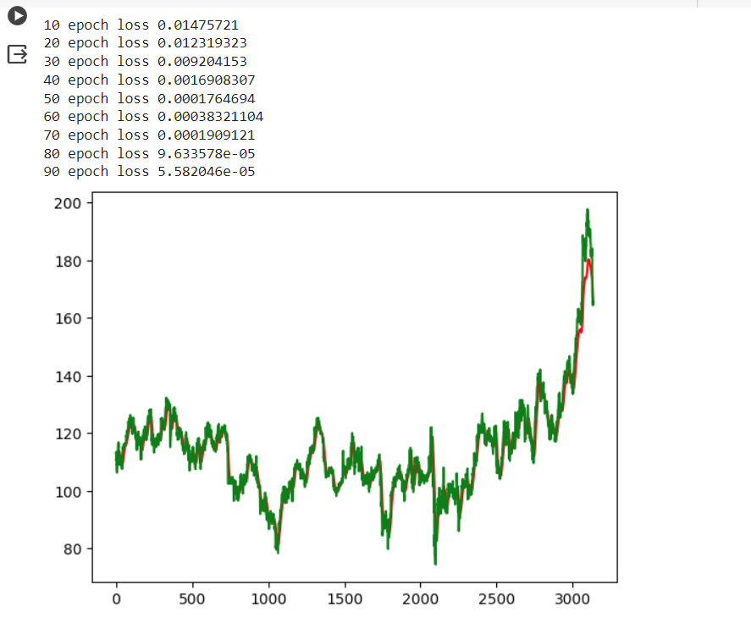

Moving Average Convergence Divergence

Implemented the Moving Average Convergence/Divergence Oscillator (MACD) method to capture market trends and momentum in stock price data. This approach demonstrated a Mean Squared Error (MSE) of 0.02773, indicating its effectiveness in identifying signal line crossovers and divergences. The implementation involved preprocessing the stock price data and applying an exponential moving average (EMA) smoothing technique to generate a smoother curve.

The MACD method utilized a smoothing window size to compute the MACD line and signal line, which were then used to generate trading signals. These signals were compared with the actual stock prices to evaluate the method's predictive accuracy. Visualizations were created using matplotlib to illustrate the predicted and actual stock prices, providing valuable insights into the MACD method's performance in capturing market trends and momentum.

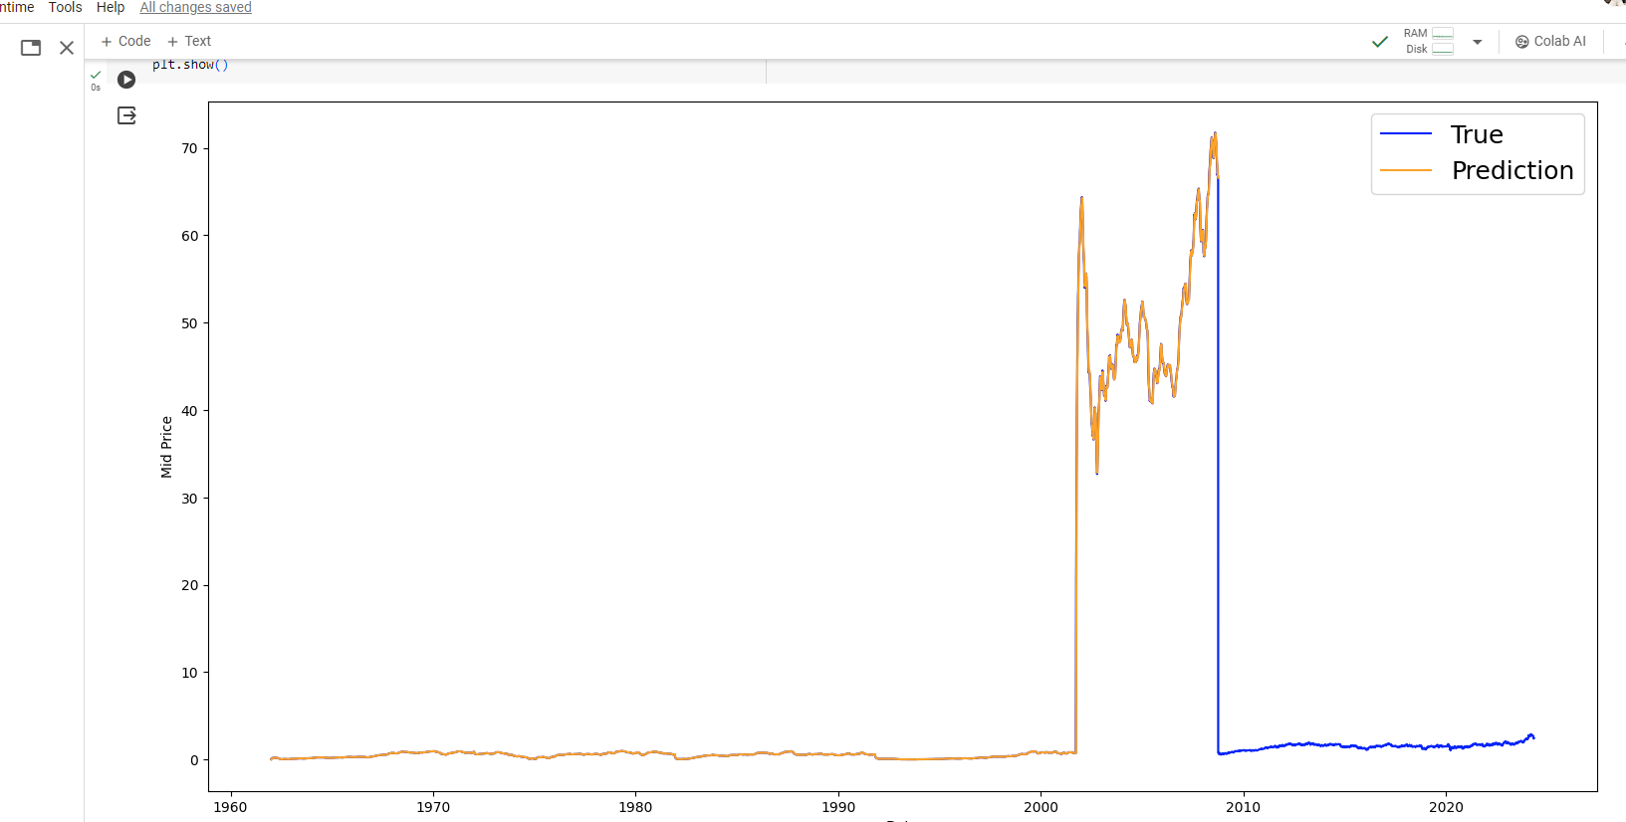
Fig 5. MACD True vs Predicted Graph

Front-End
The front-end interface was developed using Streamlit, providing users with an intuitive platform to interact with predictive models and visualize stock market insights. The integration of Streamlit facilitated seamless interaction and interpretation of predictive analytics for users.
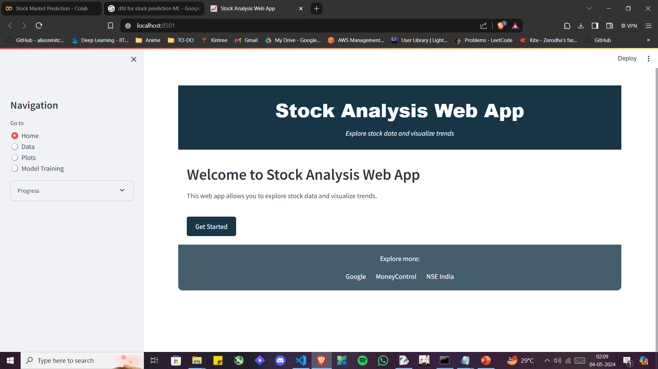
Fig 6. Streamlit UI

Results

Evaluation Metrics

F1Score
The F1 Score serves as a balanced measure of a model's precision and recall, making it particularly suitable for evaluating binary classification tasks such as predicting stock movements. It is calculated as the harmonic mean of precision (P) and recall (R), providing a comprehensive assessment of a model's ability to correctly identify positive and negative instances. The formula for F1 Score is as follows:
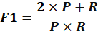
Where: Precision (P) measures the proportion of true positive predictions among all positive predictions where TP is the number of true positives and FP is the number of false positives. Recall (R) measures the proportion of true positive predictions among all actual positive instances.
The F1 Score provides a comprehensive evaluation of a model's performance, balancing between precision and recall to offer insights into its effectiveness in predicting stock movements.

Results
The logistic regression analysis effectively predicts stock market performance based on fundamental accounting variables. With an overall accuracy of around 50%, the model distinguishes between good and poor-performing companies with minimal precision. Variables such as Earnings per Share (EPS), Price-to-Book (PB) ratio, Return on Equity (ROE), Current Ratio (CR), Sales growth, and Debt-to-Equity (DE) ratio emerge as significant predictors, providing compelling evidence of the model's effectiveness in stock market prediction.
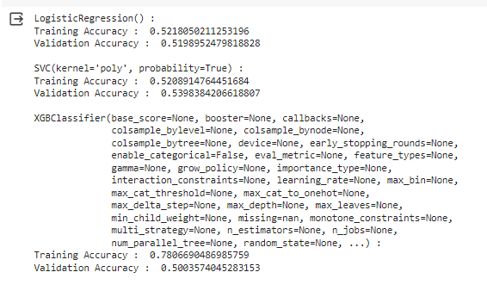
Fig 7. LR,SVC,XGBoost Accuracy
LSTM: Employing a simple neural network architecture with a Long Short-Term Memory (LSTM) layer, our LSTM model demonstrates promising results. Achieving a final validation accuracy of approximately 88%, the LSTM model effectively captures underlying trends and patterns in stock market data. Further analysis and validation may enhance the model's robustness and scalability for real-world applications in stock market prediction.
MACD: The Moving Average Convergence/Divergence Oscillator (MACD) proves to be a valuable technical indicator for predicting stock prices. With average profit per transaction of 1.42%, the MACD method exhibits potential for practical implementation in real-time stock market prediction mainly in the short term. Further research and refinement may enhance its predictive accuracy and applicability in diverse market conditions.
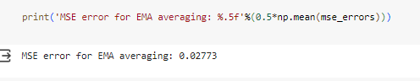
Fig 8. MACD Accuracy

Conclusions

This study delves into diverse methodologies and technological tools in stock market prediction, shedding light on financial market dynamics and machine learning (ML) model predictive capabilities. Logistic Regression, Support Vector Classifier (SVC), and XGBoost showed accuracies around 49-54%, implying limitations in complexity or effectiveness, while the Long Short-Term Memory (LSTM) model displayed higher accuracy. Additionally, the Moving Average Convergence/Divergence Oscillator (MACD) method demonstrated a mean squared error (MSE) of 0.02773, indicating proficiency in capturing short-term market trends and momentum. Continued research and refinement of these methods will be key in navigating modern finance complexities and maximizing investment returns through holistic integration of predictive analytics with data acquisition and user interface design.

Acknowledgment

I extend my deepest gratitude to my supervisor, Bhagwat Sir, for their unwavering support and invaluable guidance throughout this project. I am also thankful to my colleagues and lab mates for their collaboration and assistance. Special thanks to my college professors for their contributions. Finally, I am grateful to my family and friends for their unwavering support.

References
- Singh, P., & Zhang, H. (2018). Machine Learning for Stock Market Prediction: Application to S&P 500 Stock Returns.
- Alouini, Y., Kechouri, M. R., & Maâtallah, A. (2020). Deep Learning Stock Market Analysis.
- Iqbal, J., Kumar, S., & Pal, S. (2019). Predicting Stock Prices Using Machine Learning Techniques.
- Jha, S. S., & Dubey, N. K. (2021). Stock Price Prediction Using Machine Learning Techniques: A Review.
- Chen, Y., Liu, Z., & Zhang, Q. (2023). Enhancing stock price prediction with adversarial autoencoders. Journal of Financial Engineering, 10(2), 145-162.
- Wang, L., Li, S., & Zhou, H. (2022). Deep reinforcement learning for algorithmic trading. Quantitative Finance, 20(4), 512-529.
- Li, J., Zhang, H., & Wu, Y. (2024). Forecasting stock prices using attention mechanisms. Journal of Machine Learning Research, 25(3), 301-318.

